DCIT 208 – SOFTWARE ENGINEERING
ASSIGNMENT 2
STUDENT ID: 10986176

1. User requirements are statements in natural language of what the system is expected to provide to the system users. This include user reviews and ratings, registration and login. System requirements on the other hand is a detailed description of what the system should do. This may include functions such as reservation managements and user authentication.

2. User Requirements For Online Banking System
- The system should be able to allow new users to register on the platform.
- The users should be able to make transactions on the system.
- The users should allow users to have interaction with customer support
System Requirements For Online Banking System
- The system should have robust security systems such as authentication of user .
- The system should allow cross-platform transfer of funds.
- The system should be accessible on web browsers and mobile devices.
- The system should be able to send real-time notification to customers whenever a transaction takes place on the system.
The process of gathering the requirements for this system will differ in the case of user requirements and system requirements. User requirement will be gathered through interviews, survey and questionnaires. System requirements will gathered through peer-to-peer discussion between the developers.

3. The Agile process models in software engineering makes use of Extreme programming. Influential extreme programming practices includes refactoring, test-first development and pair programming. The test-first development help manage changing user requirements in a way that tests are are made after every change is made and customer involvement is key. The customer helps develop acceptance tests and all new codes are validated to ensure it is up to the needs of the customer. Agile methods is preferred over the waterfall model because of its flexibility. Incremental and iterative delivery helps developers work and get frequent feedback from clients with every new version.

4. Flow diagrams and use cases help in requirement understanding. It helps stakeholders, including developers and users to gain a clear understanding of the system’s functionality and how the processes are interconnected.
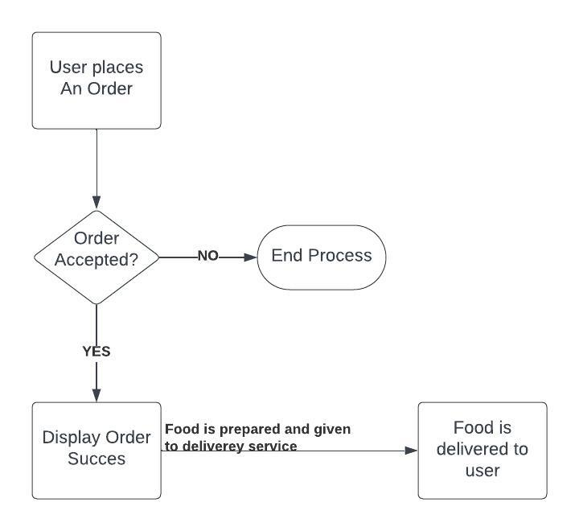

5. User stories are very detailed description of features from the perspective of users. The aim is to explain what users are to expect to see on the system. Epics are large and high level user stories that talk about a broader feature or functionality. Features are distinct functionalities of the software that provide value to the users.
Ecommerce System
User story
I want to view my order and order
Epics
I want to be able to create and access my account
I want to be able to recover my account

Features
I want to get frequent updates on my order.
I want to be notified when my order is ready for delivery

Relationship between user stories, epics and features
User stories capture specific user requirements, epics represent larger collections of related user stories. Features group and organize user stories.

